**Problem Solving Process**

**Class 8**

**Lab 9**

|  |
| --- |
| Lab Objectives:  * Constants and Variables * Data Types * How the Computer Stores Data * Functions * Operators |

# Selection_002Important Concepts to Learn

# Variable

## IMG_256In programming, a variable is a value that can change, depending on conditions or on information passed to the program.

# Constant

## A constant is a specific number or a symbol that is assigned a fixed value. For example, in the equation below, "y" and "x" are variables, while the numbers 2 and 3 are constants.

## IMG_256Constants are also used to store fixed values.

# Constant vs Variable in Programming

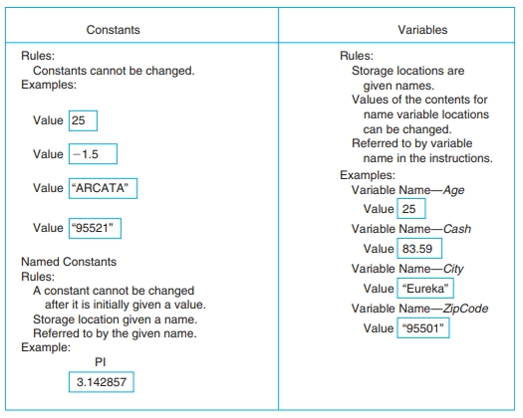

# Rules for Naming and Using Variables

## There are a number of rules for naming and using variables, as listed below. Table 2.2 illustrates some examples of incorrect variable names.

## 1. Name a variable according to what it represents, that is, Hours for hours worked, PayRate for rate of pay, and so on.Create as short a name as possible but one that clearly represents the variable.

## 2.Do not use spaces in a variable name; for example, use HoursWorked.

## 3. Start a variable name with a letter.

## 4. Do not use a dash (or any other symbol that is used as a mathematical operator) in a variable name. The computer will recognize these symbols as mathematical operators, turn your variable into two or more variables, and treat your variable as a mathematical expression.

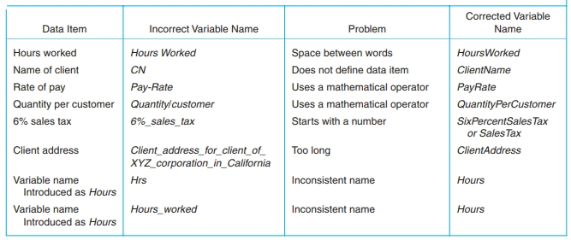

# Data Types

## Selection_005a data type or simply type is a classification of data which tells the compiler or interpreter how the programmer intends to use the data.

## There are five basic data types associated with variables:

## int - integer: a whole number.

## float - floating point value: ie a number with a fractional part.

## double - a double-precision floating point value.

## char - a single character.

## void - valueless special purpose type which we will examine closely in later sections.

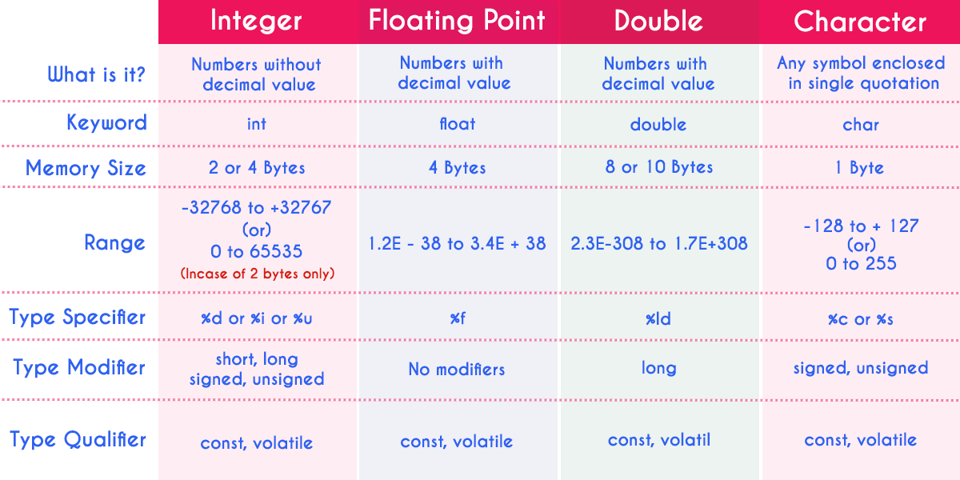

# How the Computer Stores Data

## The computer stores data internally in memory locations. These data are found by the variable names used by a program. Each variable name is given a memory location, and each memory location can hold one and only one value at a time. When a user enters a new value into the variable location, the previous value is destroyed.

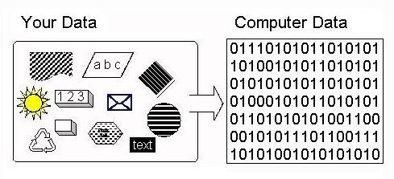

## These memory locations are temporary, as the internal memory is a volatile memory. When a program completes its instructions, and/or when the computer is turned off, the values stored in the internal memory are destroyed.

## Data and instructions are temporarily stored in the computer’s internal memory during the processing. When data, information, or programs have to be kept for future Data Storage use, they are stored externally on an external storage medium such as a hard disk drive in storage areas called files.

## There are basically two types of files: program files and data files. Program files contain the instructions to tell the computer what to do. This book helps the programming student create programs that will be saved on the external storage device as program files. Data files contain the data required to execute the program files.

## IMG_256

# Function

## Functions are small sets of instructions that perform specific tasks and return values. They are usually built into a computer language.

## Functions are used as parts of instructions in a solution. Because they are basic tasks that are used repeatedly in the problem solving process, by using them a programmer or user can shorten the problem-solving time and improve the readability of the solution.

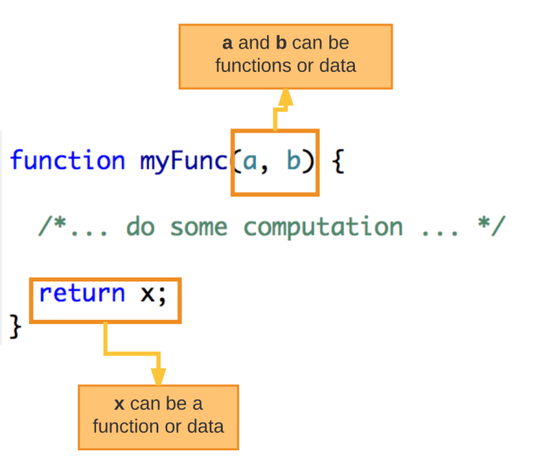

# How Function Works?

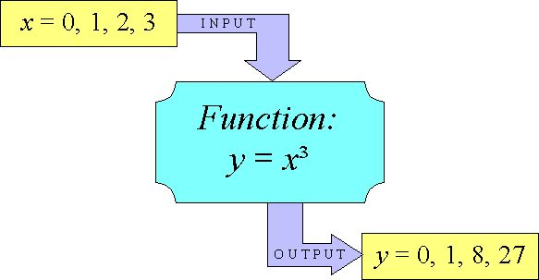

# Operators

## The computer has to be told how to process data. This task is accomplished through the use of operators. Operators are the data connectors within expressions and equations.

## They tell the computer how to process the data. They also tell the computer what type of processing (mathematical, logical, or whatever) needs to be done.

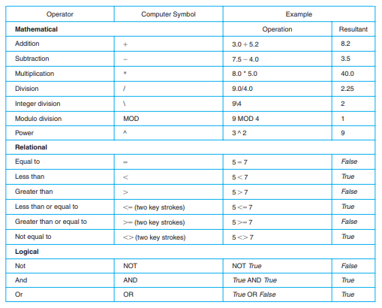

# Expressions and Equations

